**Bug Report Template**

|  |  |
| --- | --- |
| ID number* | 13 |
| Title* | HomePage – Afisarea unei imagini necorespunzatoare si cosul de cumparaturi asezat incorrect in pagina |
| Reporter* | Ana B |
| Submit Date | 08/05/2024 |
| URL | www.saucedemo.com |
| Platform (optional) | Windows |
| Operating System (optional) | 10 |
| Browser (optional) | Chrome 53 |
| Severity* | Major |
| Assigned to | / |
| Priority* | Critical |

**Description**\*

Apare o imagine necorespunzatoare in Home Page care acopera poza primului produs din lista de produse si butonul cosului de cumparaturi este asezat gresit in pagina

**Steps to reproduce**

1 accesam site’ul www.saucedemo.com

2 in campul “username” introducem “visual_user”

3 in campul “password” introducem “secret_sauce”

3 click login buton

**Expected result**

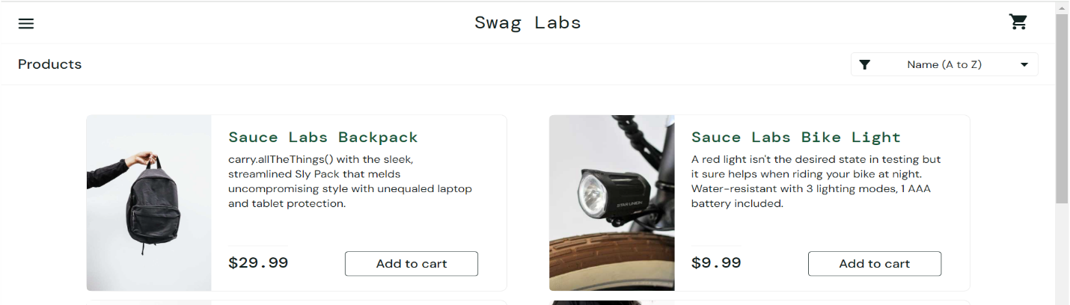

**Actual result**

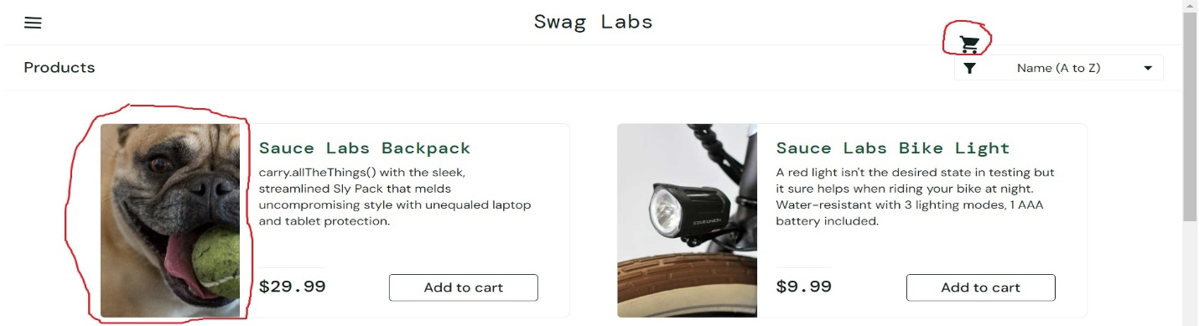

**Notes**